**EXPERIENCE LETTER**

<<LWD DD/MM/YYYY>>

**TO WHOMSOEVER IT MAY CONCERN**

This is to certify that **Mr/Ms. <<Full Name>>** was in the employment of our organization and his/her employment particulars are mentioned below:

Name: **<<Full Name>>**

Employee ID: **<<Emp ID >>**

Designation: **<<Designation >>**

Date of Joining: **<<DOJ DD/MM/YYYY>>**

Last Working Date: **<<LWD dd/MM/YYYY>>**

CTC: **$ <<CTC>>/-** (USD **<<CTC in words>>** only)

We wish **<<First Name>>** all the best in his/her future endeavors.

Yours sincerely,

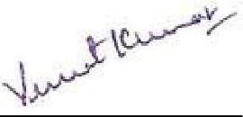

Vineet Kumar

Co-founder, CEO-US

Affine Inc.